Portable Clocking Machine

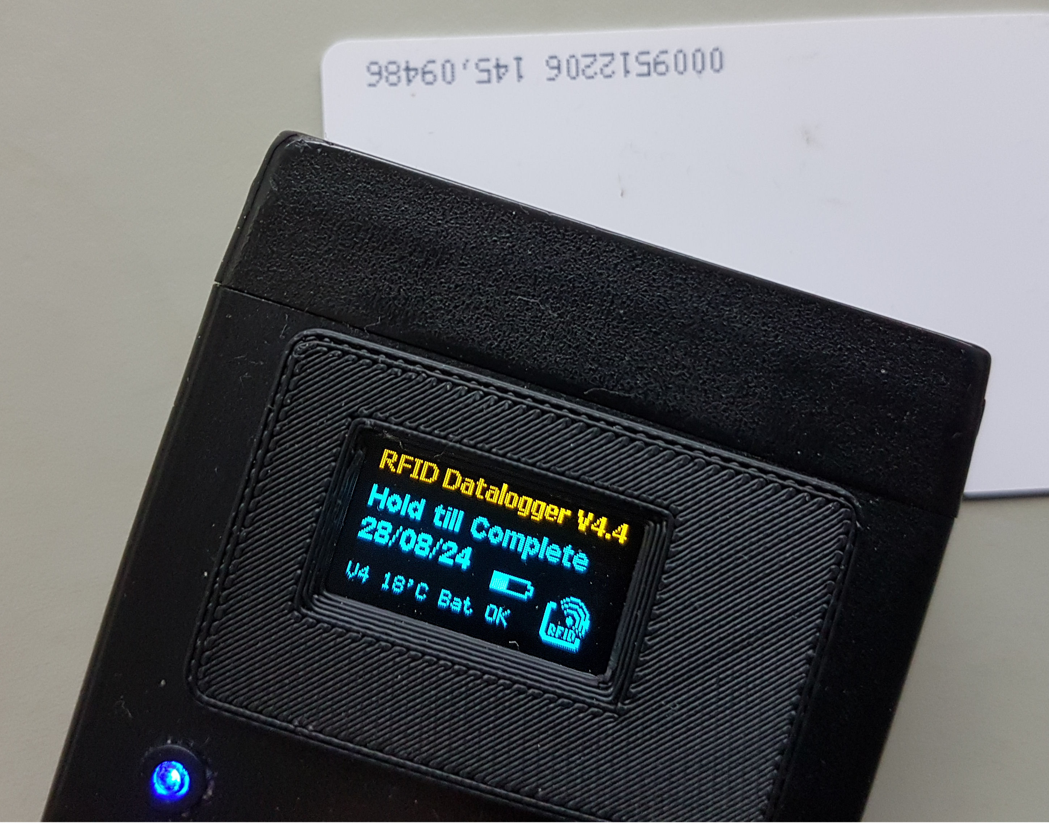

Contents:

Table of Contents
Introduction 2
The physical design 2
The Build 5
Vero board 5
RFID Reader 6
DC to DC converter 7
Arduino 7
LED 8
Real Time Clock (RTC) 8
Battery holder 10
Casing 10
Arduino set up 12

Portable Clocking Machine

Introduction
This portable logger was initially developed for a care agency to log the attendance of the care workers at service user’s house.

The portable logger could also be used to track time on bicycle races where it could track positions at different stops where RFID tags could be placed at these locations.
The date is in a CSV file format which could be opened with any Office software.
The design is simple, however I hit the limitations of Arduino with the allocation of variables, so the software got more complicated than necessary as all String variables had to be replaced with Char Arrays which is more difficult to work with.
An Arduino Nano is used as the base processor. As this processor has not got a real time clock, initially DS1307 was used as the clock, however it was found that this module is not keeping accurate time and later was replaced with DS3231 which compensate for temperature to provide a more stable time. The logger also logs the temperature and the battery voltage for further accuracy analysis.
125KHz RFID reader RDM6300 was used as it could be purchased for less that £2.
The full size SD card reader was used as the limitation appears to be 2GB, so any small SD or micro SD with the adapter could be used. I must admit getting hold of 2GB cards proved difficult, however they are still available to purchase.
3 AAA battery is used as they fit comfortably in the used case. A DC to DC converter is used to provide a steady 5V supply to the circuit from either 2 AA or 3 AAA supply batteries.
The initial design used an LCD display, however they use a lot of battery and the final design was based on an OLED.
Working with OLED allowed the ability to create RFID Logo, Battery sign and other characters such as the degree sign that is not available in the standard character set.
3x3 characters (1-9) of the 8x8 character font sets were changed to represent the logo. Spreadsheet template was used to calculate the required values for each of the nine characters.

The physical design
Arduino Nano has all the digital and analogue connections of the Arduino Uno but it is small enough to be used in a portable device. The Arduino mini could also be used but the mini has not got the USB interface and could not be directly programmed without another interface.

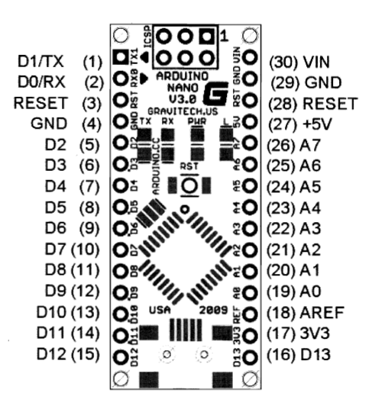

The RTC is connected to the Arduino using I2C bus which is the most common way. The clock SCL is connected to A5(Analogue 5) and SDA is connected to A4(Analogue 4) pin of the Arduino.

RFID 125KHz tag reader is connected to the Processor using a single line to D2 (Digital 2). This is because there is only RX connected and the TX is ignored as we don’t intend to write to the tag.

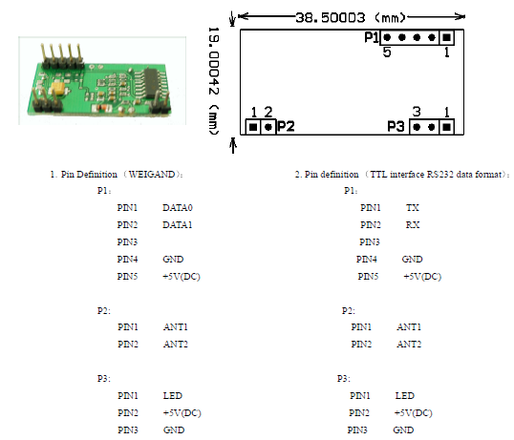

The design of the SD card reader is taken from the standard Data logger shield with the exact connection to the Arduino, so in effect the software is interchangeable between the two. This also implies to the RTC as the Data logger shield also has a Real Time Clock.

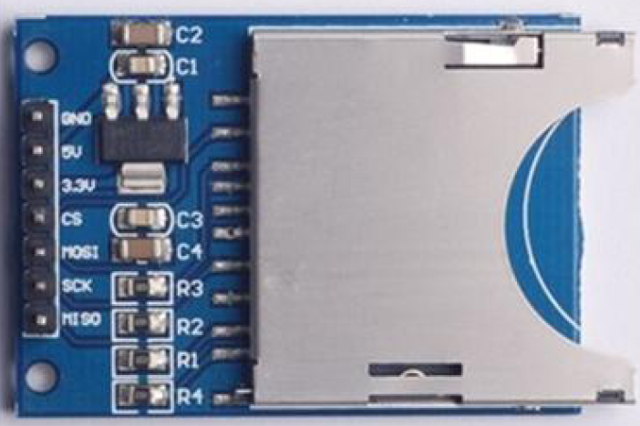

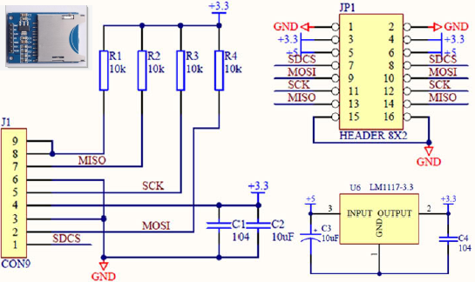

DC to DC converter is used ensure that the voltage remains 5V. The input voltage pins are placed on top of the converter and also there is a facility to generate other voltages via D+ and D- pins which are not used. So only Top pins (IN+ and IN- GND and 5V pins are used).

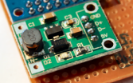

There is an 8x2 LCD JHD571 which could be purchased from suppliers outside UK. These are a variety of these LCDs and the selected ones are Blue with Backlight. The ones that were originally purchased from Farnell did not have the backlight.

These 8x2 devices are not I2C interface and need to be connected vial digital lines. Fortunately only 4 bit data is required, therefore it is connected to D4, D5, D6 and D7 of Arduino. Apart from data and power (5V and GND), the display also needs the RS Register Selector (D8) and Enable (D7) pins connected, so 8 pins in total are connected.
The R/W is grounded and there is a 10K (or 20K) pot connected to the 5V and 0V and selectable voltage for contrast.

These LCDs were later replaced with Yellow-Blue 64x128 OLEDs

The DS1307 RTC was also replaced with the DS3231 AT24C32 IIC which is the direct pin equivalent of DS1307 and used the same library.

The 4 pins of RTC and OLED (i.e. GND, VCC, SCL, SDA) were connected together.

The Build

Vero board
Vero board is used as this is a very small quantity and does not justify the expense of PCB.

There are a couple of problems with the Veroboard that needs very careful consideration and they both relates to the SD card reader module.

The SD card reader pins are not suitable for the Veroboard, so apart from the ground, all other pins are soldered above the board.

The second problem is that the SD cards reader sits attached to the board and the wires are soldered outside using the screened 22Gauge wire.

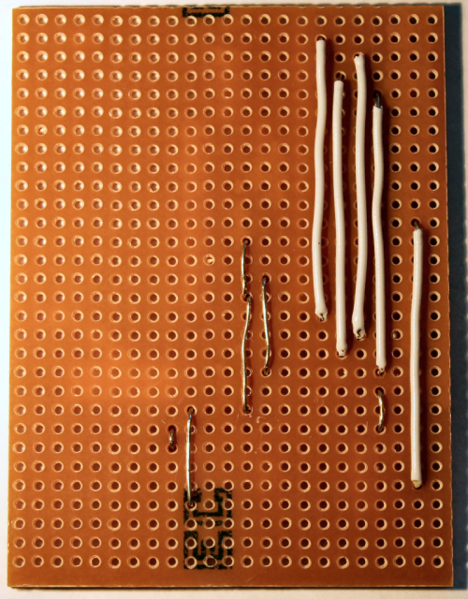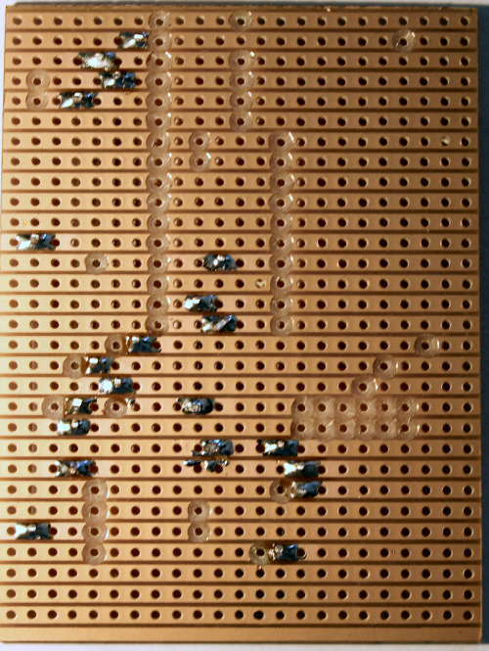

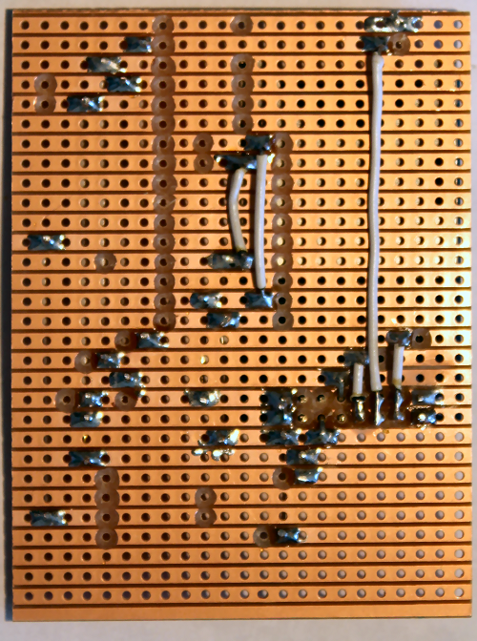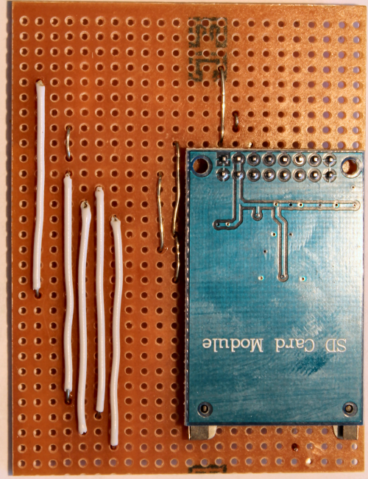

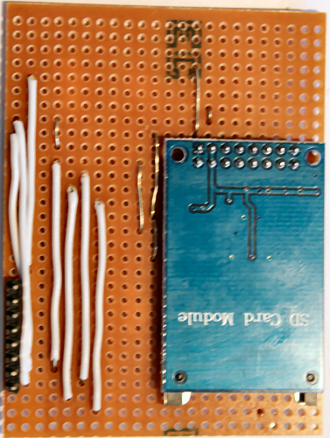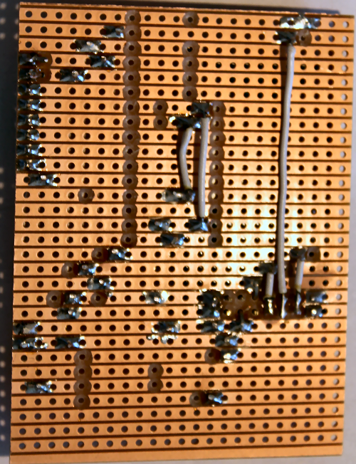

RFID Reader
De-solder the 3 pin that is not used as it short the other items on the box.

Bend the 5 pin connector to 90° such that the RFID reader is connecting vertical to the board.

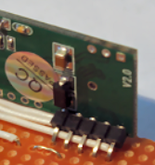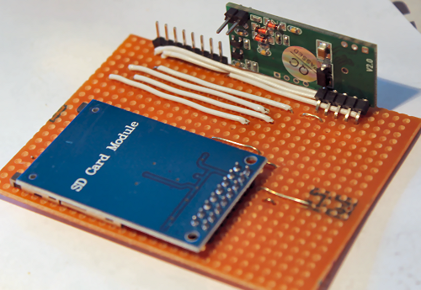

DC to DC converter
With the DC to DC converter, the 4 pin connector is used to attach it to the Veroboard but the IN+ and IN- are connected using wire.

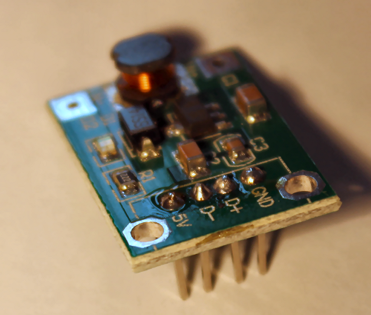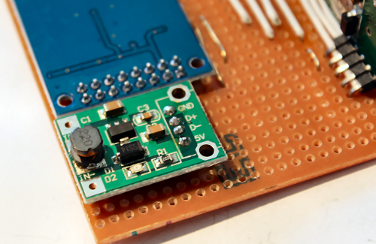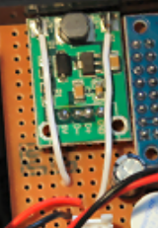

Arduino
With the Arduino Nano, the six pins at one side of the board that are not used are chopped to create more room for wires inside the box.
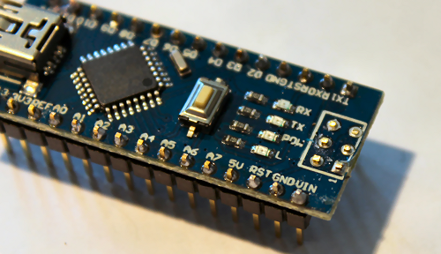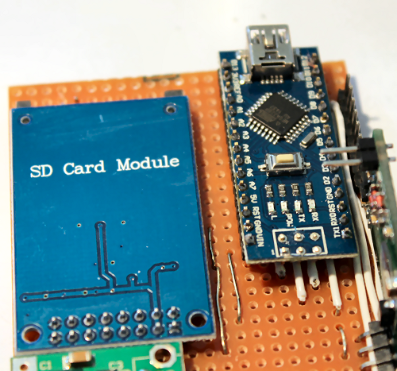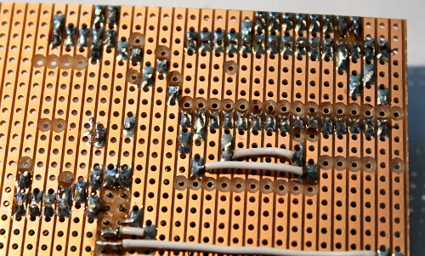

The wires at the back of the veroboard need to be carefully soldered to ensure that they won’t short if it is squeezed inside the box and excess chopped to avoid get short with RFID coil.

LED

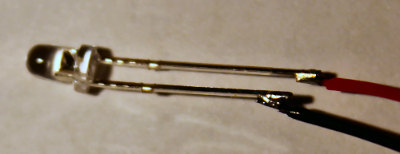
With the LED, the long pin is + and the short Pin is –

Real Time Clock (RTC)

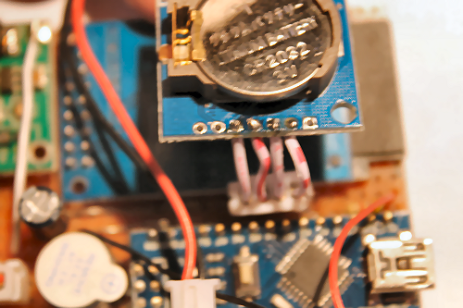

Initially DS1307 was used as the Real Time Clock, however due to accuracy issues it was replacement with DS3231 AT24C32 IIC which keep the time better due to its ability to compensate for temperature etc.

The RTC is wired using a 4-pin connector. Ensure that you connect 4 wires to the side with 7 pins and not the other side which has pins and put Duck tape on the back of SD card reader and normal tape over the RTC to stop it from shorting.

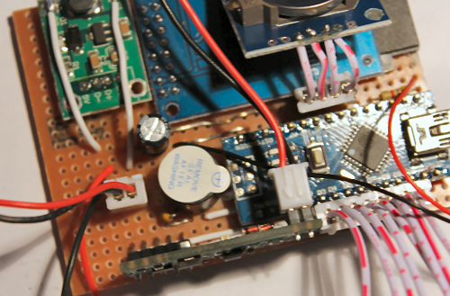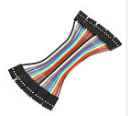

The 4 pin cable is ½ of the 10cm 2.54mm 4 Pin Female to Female F/F Jumper Wire Cable Connector.

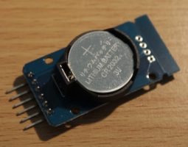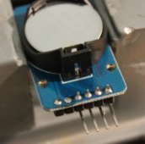

First need to break the strip at the end of the board and de-solder all pins.
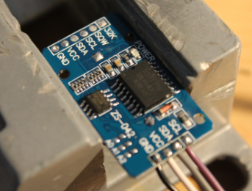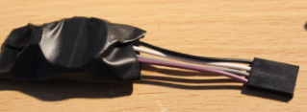

Solder 4 wires with black (or a colour representing Ground) at one side for identification.

Trim the sharp end of the battery holder pins and any left over wire from the solder as this module is going to sit over the DC to DC regulator, so to avoid short use tape to cover any exposed wire or circuit.

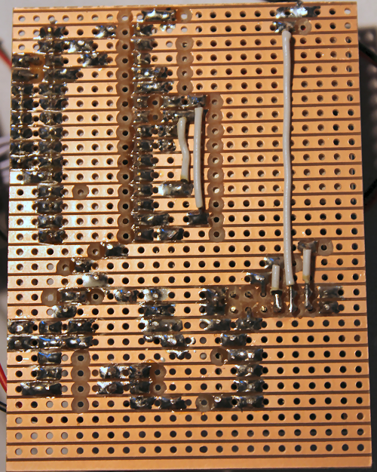

Battery holder
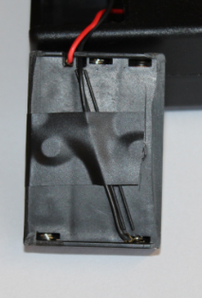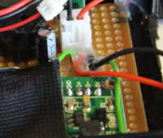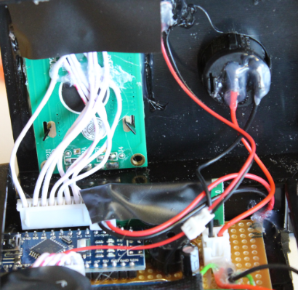

Shave the sides of the battery holder to make it easier to go inside the box. One side the shavings should be more in the middle to stop it from catching on the on-off switch as it goes inside the box.

Also put some hot glue on the wires on the board (near the switch connector) to stop wires from detaching from the board when you change the batteries.

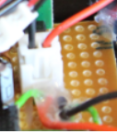

Casing
Use template to mark the box
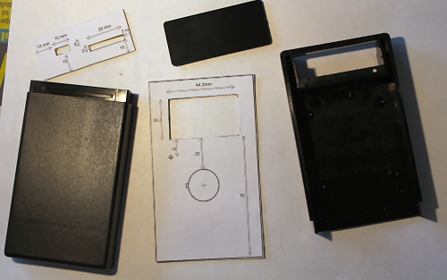
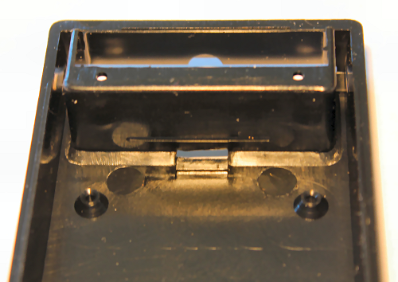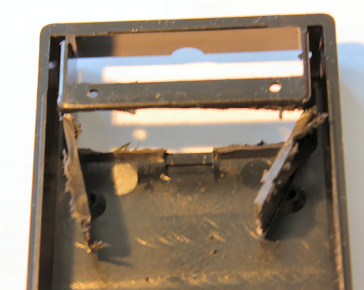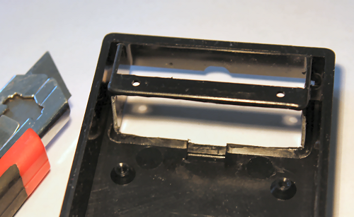

The battery place in the box needs to be cut out carefully such that the 3AAA battery holder goes in without damaging the two screw that holds the box together.

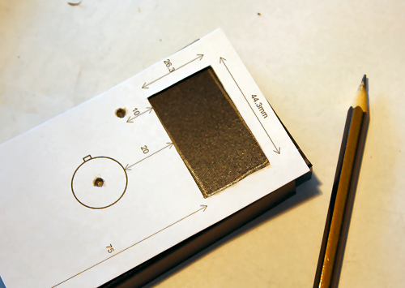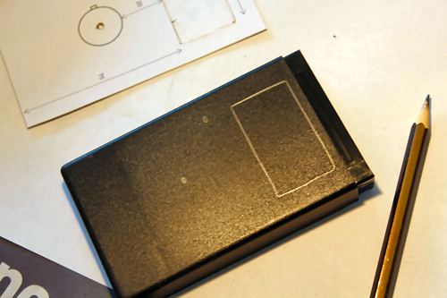

Once you’ve done the marking, ensure that they are correctly positioned and are at the centre before drilling.

The drill used for the veroboard is the same as the one used for the 3mm LED.

The switch hole needs to be drilled carefully, too tight and the switch won’t operate and too loose, the switch would not be secure.

The same thing applies for the LCD, its best to cut the hole a bit small and enlarge it using Stanley knife.

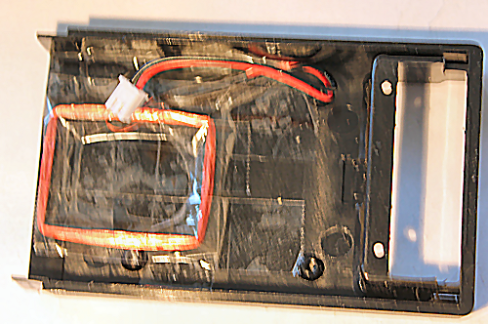

The RFID coil needs to be taped at the bottom of the box with the cable coming out on one side near the battery slot. Once finished stick more tape over it to ensure that any sharp solder at the bottom of the vero board does not short the RFID coil.
Also cover it with the Duck tape.

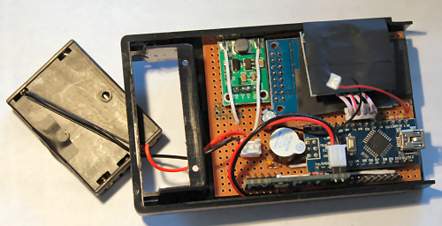

Also tape over both side of the RTC to ensure that it does not short the SD card Reader or the LCD.

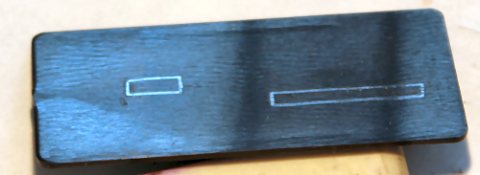

Use the mask for this.

Arduino set up
The Arduino used is ‘arduino-1.0.6-windows.exe’ It may or may not work with other versions, but the instructions would be different.

http://www.arduino.cc/en/Main/Software

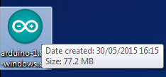
Install software

Install driver for Arduino
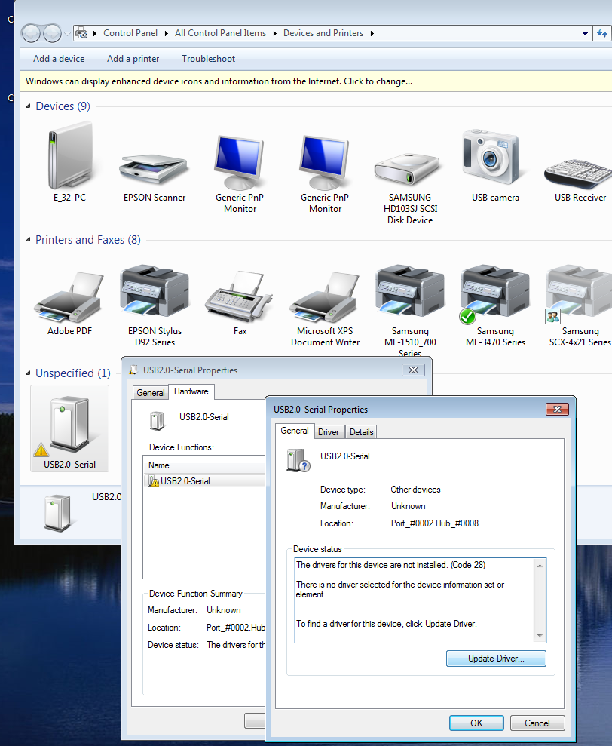

The driver is in F drive
Driver - CH341SER folder

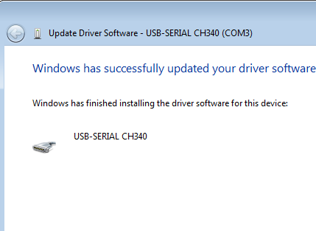

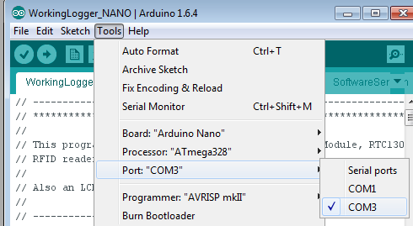

Select the Com that it installed the driver, in this case Com3

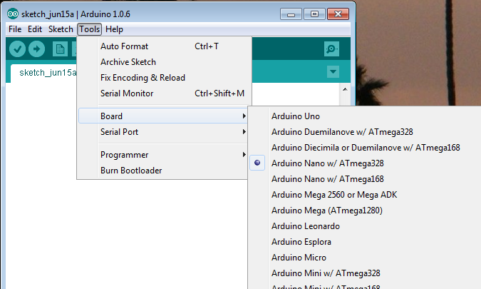

Select Arduino Nano with Atmega328 Board

